National College of Ireland

**Ethical Guidelines and Procedures for Research involving Human Participants**



October 2019

Joey Tatú  
15015556

ETHICS FORM FOR SCHOOL OF COMPUTING:  
Body Modifications Appointments (BMA)

**Ethics Application Checklist**

To be submitted alongside the ethics application.

Please complete the below checklist, ticking each item to confirm that it has been addressed.

|  |  |
| --- | --- |
| 1. I agree to obtain informed written consent from all human participants aged over 18 who are involved in this research (or if circulating digitally, I will ensure that informed consent is completed, and will have the participants indicate their informed consent by continuing with their study engagement). 2. I agree to obtain informed written consent from the parents of anyone aged under 18 in this research (or from the schools if appropriate), and informed written assent from those under 18 in this research. 3. I include a letter of agreement from a clinically responsible individual agreeing to (where appropriate) help me recruit/provide clinical support in the event that participants become distressed/host the study data collection. 4. I append a letter of agreement from an external institution or organisation agreeing to host the study. 5. I agree to comply with NCI’s Data Retention Policy. 6. I have appended a) information sheet, b) consent form/assent form, c) debriefing sheet. 7. I have provided details of how non-anonymised data will be stored, in a safe and encrypted manner. 8. I have included my contact details and those of my supervisor (where appropriate). I have only included my NCI email address and not included any personal contact information. 9. I have given sufficient details on the proposed study design, methodology, and data collection procedures, to allow a full ethical review, and I understand that my failure to give sufficient detail may result in a resubmission being required. 10. I understand that if I make changes to my study following ethical approval, it is my responsibility to seek an ethics amendment if the change merits ethical consideration. | ☑️  ☑️  ☑️  ☑️  ☑️  ☑️  ☑️  ☑️  ☑️  ☑️  ☑️ |

**National College of Ireland**

**Human Participants Ethical Review Application Form**

All parts of the below form must be completed. However, in certain cases where sections are not relevant to the proposed study, clearly mark NA in the box provided.

Part A: Title of Project and Contact Information

**Name**

Joey Tatú

**Student Number (if applicable)**

15015556

**Email**

[x15015556@student.ncirl.ie](mailto:x15015556@student.ncirl.ie)

**Status:**

Undergraduate ☑️

Postgraduate □

Staff □

**Supervisor (if applicable)**

Paul Stynes (assumed)

**Title of Research Project**

Body Modification Appointments (BMA)

**Category into which the proposed research falls (see guidelines)**

**Research Category A** ☑️

Research Category B □

Research Category C □

**Have you read the NCI Ethical Guidelines for Research with Human Participants?**

Yes ☑️

No □

**Please indicate any other ethical guidelines or codes of conduct you have consulted**

N/A

**Has this research been submitted to any other research ethics committee?**

Yes □

No ☑️

**If yes please provide details, and the outcomes of this process, if applicable:**

N/A

**Is this research supported by any form of research funding?**

Yes □

No ☑️

If yes please provide details, and indicate whether any restrictions exist on the freedom of the researcher to publish the results:

N/A

Part B: Research Proposal

Briefly outline the following information (not more than 200 words in any section).

**Proposed starting date and duration of project**

October 2019 – May 2020

**The rationale for the project**

More people today are interested in getting tattoos and piercings to express themselves. Research shows that booking a tattoo or piercing appointment can be tedious for both the tattoo artists and piercers (artists) and customers.

The project is about creating a website for appointments for artists and their customers. From personal experience, miscommunication from both parties can occur. With the web application, this will make it easier to make appointments and for artists to manage their time correctly.

**The research aims and objectives**

BMA is a web application designed for managing appointments with tattoo artists, piercers and body modifiers and their customers. The application has two types of accounts; artist and customer.

The artist can declare which days they are free and customers can book appointments on these selected days and times. The system will manage available and unavailable days and times. The key feature of this web application is if a regular customer has not booked an appointment in a while, the system will contact the customer. This will be implemented by Artificial Intelligence.

Customers will be informed by email and text message of their appointment one day before their appointment. Artists will get daily or weekly notifications on what days and times have appointments. Payment is also handled via the web application. It is expected PayPal will be used for this.

The aim of this project is to design, implement, test and evaluate this web application.

**The research design**

A number of people who use social networking websites and apps will be contact in order to elicit requirements. Based on that outcome, the functionality around these of the application will be designed and then implemented.

The application will be tested and checked for errors using Unit Testing.

Gathering the requirements will require human participants who are over the age of 18 and they will provide feedback on the functionality of the website, such as what features would be more valuable.

Participants permission for data gathered in this project to be used for research purpose is obtain.

The feedback will be collected through an online survey. The survey is anonymised and therefore no personal data is collected.

The collected feedback will be analysed and used to improve the application. An overall description of the answers received in the survey will be presented in the Mid-Point documents at the end of December 2019.

**The research sample and sample size**

**Please indicate the sample size and your justification of this sample size. Describe the age range of participants, and whether they belong to medical groups (those currently receiving medical treatment, those not in remission from previous medical treatment, those recruited because of a previous medical condition, healthy controls recruited for a medical study) or clinical groups (those undergoing non-medical treatment such as counselling, psychoanalysis, in treatment centres, rehabilitation centres, or similar, or those with a DSM disorder diagnosis).**

An account on BMA will only be allowed to those over the age of 18. Participants will see example web pages on of BMA

It is expected that 20 people will participate in this sample size and answer the survey questions.

Social media sites such as Facebook and Twitter will be used to invite people to take part in this survey.

**If the study involves a MEDICAL or CLINICAL group, the following details are required:**

1. **Do you have approval from a hospital/medical/specialist ethics committee?**

**If YES, please append the letter of approval. Also required is a letter from a clinically responsible authority at the host institution, supporting the study, detailing the support mechanisms in place for individuals who may become distressed as a result of participating in the study, and the potential risk to participants.**

**If NO, please detail why this approval cannot or has not been sought.**

1. **Does the study impact on participant’s medical condition, wellbeing, or health?   
   If YES, please append a letter of approval from a specialist ethics committee.**

**If NO, please give a detailed explanation about why you do not expect there to be an impact on medical condition, wellbeing, or health.**

**The nature of any proposed pilot study. Pilot studies are usually required if a) a new intervention is being used, b) a new questionnaire, scale or item is being used, or c) established interventions or questionnaires, scales or items are being used on a new population. If no such study is planned, explain why it is not necessary.**

N/A

**The methods of data analysis. Give details here of the analytic process (e.g. the statistical procedures planned if quantitative, and the approach taken if qualitative. It is not sufficient to name the software to be used).**

The survey consists of quested to be answered with a yes or no. Some questions that are included are based on a scale of “not important” to “very important”

The survey consists of yes/no questions as well as questions with answers on a 1 to 5 scale. Quantitative data will be collected via the survey and analysed.

The reporting of results will commence when all data is aggregated across all participants.

Any personal or identifiable information will not be analysed.

The results will be put into Microsoft Excel and will be used for statistical analysis and graphical representation of the results.

The results will not be displayed to the participants, unless requested by a participant.

**Study Procedure**

**Please give as detailed an account as possible of a participant’s likely experience in engaging with the study, from point of first learning about the study, to study completion. State how long project participation is likely to take, and whether participants will be offered breaks. Please attach all questionnaires, interview schedules, scales, surveys, and demographic questions, etc. in the Appendix.**

A small introduction on the reasoning of the study is given to participants and at the very start of the survey. The consent of the participant is required and retained.

Participants are then asked to download the application and open it on their mobile phone.  
  
Participants are asked to:  
- Create two types of account (artist and customer), by using a username and password  
- Upload a profile/shop photo (sample domain free images will be provided)  
- Edit their profile, editing all fields  
- Act as artist to indicate what days they can work (any date/time can be selected by the user)  
- Act as customer to book and pay for their appointment (any date/time/amount can be selected by the user)  
- Send a message to an example customer (as artist)  
- Send a message to an example artist (as customer)

Once these are done, the participants are asked the questions in the survey.

This evaluation will take no longer than 30 minutes.

**Please identify any ethical issues or risks of harm or distress which may arise during the proposed research, and how you will address this risk. Here you need to consider the potential for physical risk, social risk (i.e. loss of social status, privacy, or reputation), outside of that expected in everyday life, and whether the participant is likely to feel distress as a result of taking part in the study. Debriefing sheets must be included in the appendix if required.** These should detail the participant’s right to withdraw from the study, the statutory limits upon confidentiality, and the obligations of the researcher in relation to Freedom of Information legislation. Debriefing sheets should also include details of helplines and avenues for receiving support in the event that participants become distressed as a result of their involvement in this study.

Part C: Ethical Risk

There is no risk of harm or distress to the participants.

If a participant wishes to withdraw, they can do so at any time. Incomplete results will not be used in the results. Results where consent is not obtained, these results will be omitted.

**Do the participants belong to any of the following vulnerable groups?**

(Please tick all those involved).

□ Children;

□ The older old (85+)

□ People with an intellectual or learning disability

□ Individuals or groups receiving help through the voluntary sector

□ Those in a subordinate position to the researchers such as employees

□ Other groups who might not understand the research and consent process

□ Other vulnerable groups

**How will the research participants in this study be selected, approached and recruited? From where will participants be recruited? If recruiting via an institution or organisation other than NCI please attach a letter of agreement from the host institution agreeing to host the study and circulate recruitment advertisements/email etc.**

Participants will be invited to take part in this study by social networking sites (Facebook. Twitter and Instagram). Messaging apps like WhatsApp and Telegram will also be used.

Participants wishing to take part are on a completely voluntary basis.

**What inclusion or exclusion criteria will be used?**

Participants must be an adult (i.e. 18 years old or over) and must have an interest/use social networking and be interested in body modification.

**How will participants be informed of the nature of the study and participation?**

An invitation link will be posted on Facebook, Twitter, Instagram, WhatsApp and Telegram outlining the nature of the study

**Does the study involve deception or the withholding of information? If so, provide justification for this decision.**

N/A

**What procedures will be used to document the participants’ consent to participate?**

Before the questions in the survey, content is requested from the participant. This will be included with the link posted on social media as well as in the description of the survey. If consent is not obtained, and the participant has filled out the survey, their individual results will not be used.

**Can study participants withdraw at any time without penalty? If so, how will this be communicated to participants?**

Yes. Participants can withdraw consent at any time. Any information the said participant has provided is destroyed within 24 hours after their consent is withdrawn. Participants will be made aware of this. This will be included in the consent message.

**If vulnerable groups are participating, what special arrangements will be made to deal with issues of informed consent/assent?**

N/A

*Please include copies of any information letters, debriefing sheets, and consent forms with the application.*

Part D: Confidentiality and Data Protection

**Please indicate the form in which the data will be collected.**

□ Identified □Potentially Identifiable **☑️ De-Identified**

**What arrangements are in place to ensure that the identity of participants is protected?**

Information is provided as anonymous. Any personal information that is received will not be added to the results and will be destroyed within 24 hours.   
  
Email addresses are collected in the survey. Email addresses are used for participants to remove their answers upon their request. They will not be included in the results or be used by any other means.

**Will any information about illegal behaviours be collected as part of the research process? If so, detail your consideration of how this information will be treated.**

This is possible. The law regarding body modifications, such as implants and scarification is not fully defined. It is possible a government official (e.g. Garda, judge, etc.) could deem this as illegal.

There is a question in the survey that deals with adding an option for specific body modifications (such as body implants and scarification.

**Please indicate any recording devices being used to collect data (e.g. audio/video).**

No recording devices are used in this project.

**Please describe the procedures for securing specific permission for the use of these recording devices in advance.**

N/A

**Please indicate the form in which the data will be stored.**

□ Identified □ Potentially Identifiable □ **De-Identified**

**Who will have responsibility for the data generated by the research?**

The applicant for the Ethics approval.

Is there a possibility that the data will be archived for secondary data analysis? If so, has this been included in the informed consent process? Also include information on how and where the data will be stored for secondary analytic purposes.

No.

If not to be stored for secondary data analysis, will the data be stored for 5 years and then destroyed, in accordance with NCI policy?

**☑️** Yes □ No

**Dissemination and Reporting**

**Please describe how the participants will be informed of dissemination and reporting (e.g. submission for examination, reporting, publications, presentations)?**

No participant will be informed on the results of the survey, unless requested. If requested, the participant will see the full results from all participants (excluding participant’s emails), and will not see their or other’s individual results.

**If any dissemination entails the use of audio, video and/or photographic records (including direct quotes), please describe how participants will be informed of this in advance.**

N/A

Part E: Signed Declaration

I confirm that I have read the NCI Ethical Guidelines for Research with Human Participants, and agree to abide by them in conducting this research. I also confirm that the information provided on this form is correct (Electronic signature is acceptable).

**Signature of Applicant: Joey Tatú**

**Date 07/10/2019**

**Signature of Supervisor (where appropriate):**

**Date _____**

**Any other information the committee should be aware of?**

Survey link: [https://forms.gle/Qhto8kRArr3KwB9N6](https://forms.gle/Qhto8kRArr3KwB9N6%20)   
  
The Important Section is also included with the link and provided to the participants before they view the example website.  
  
Important section:   
“IMPORTANT:

Information you provide will be aggregated into a report with 19 other participants. This will gauge your experience of using the website. The results will not be visible to you or anyone else. You may request the results. If you do, you will view the entire results. Individual results from you or another will not be shared.

You are free to withdraw your participation at any time. You can email joey.tatu@student.ncirl.ie to remove your answers at any time (Please provide your email address you used on this form). Your email address if required so your answers can be destroyed at your request.

If you withdraw your participation, consent or answers, information you provided will be destroyed within 24 hours upon your request. No personal information will be received. Any personal information provided will be destroyed within 24 hours after completing this survey. Your consent is required and recorded. If you do not consent, do not complete this survey.”

**APPENDIX A – SURVEY QUESTIONS**

Include here the questions from the survey to be answered by the participants

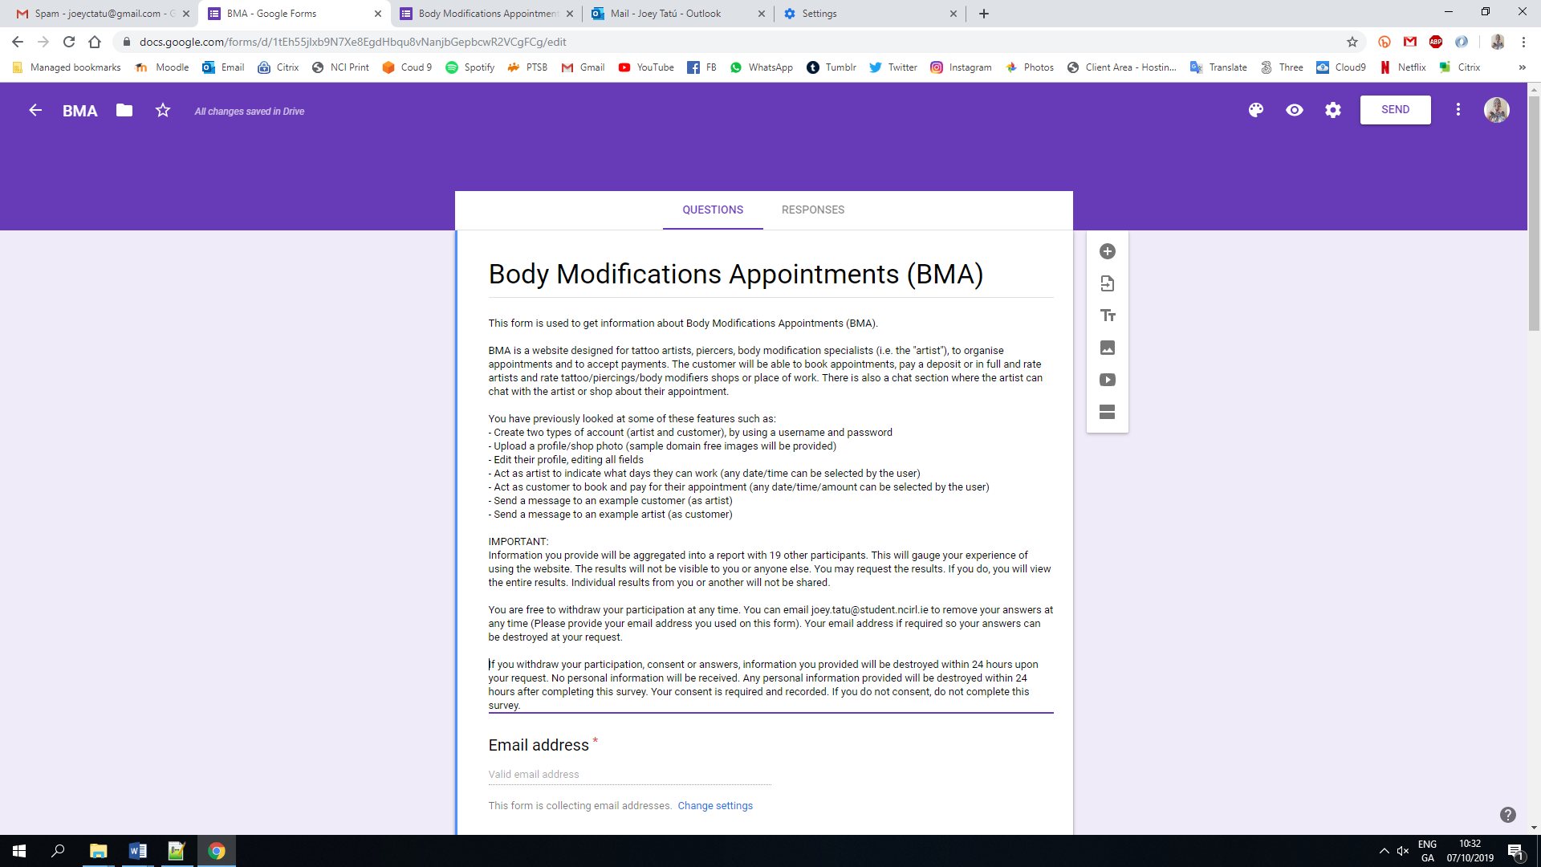

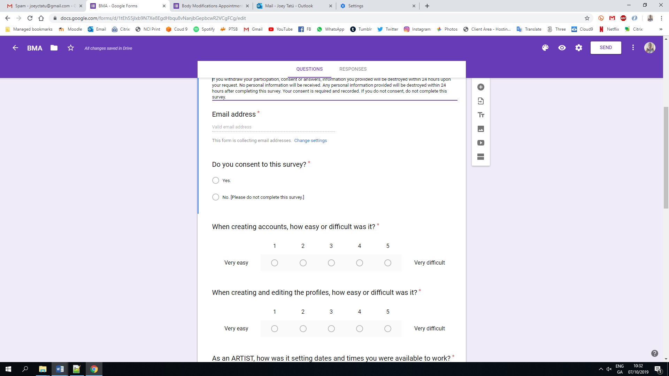

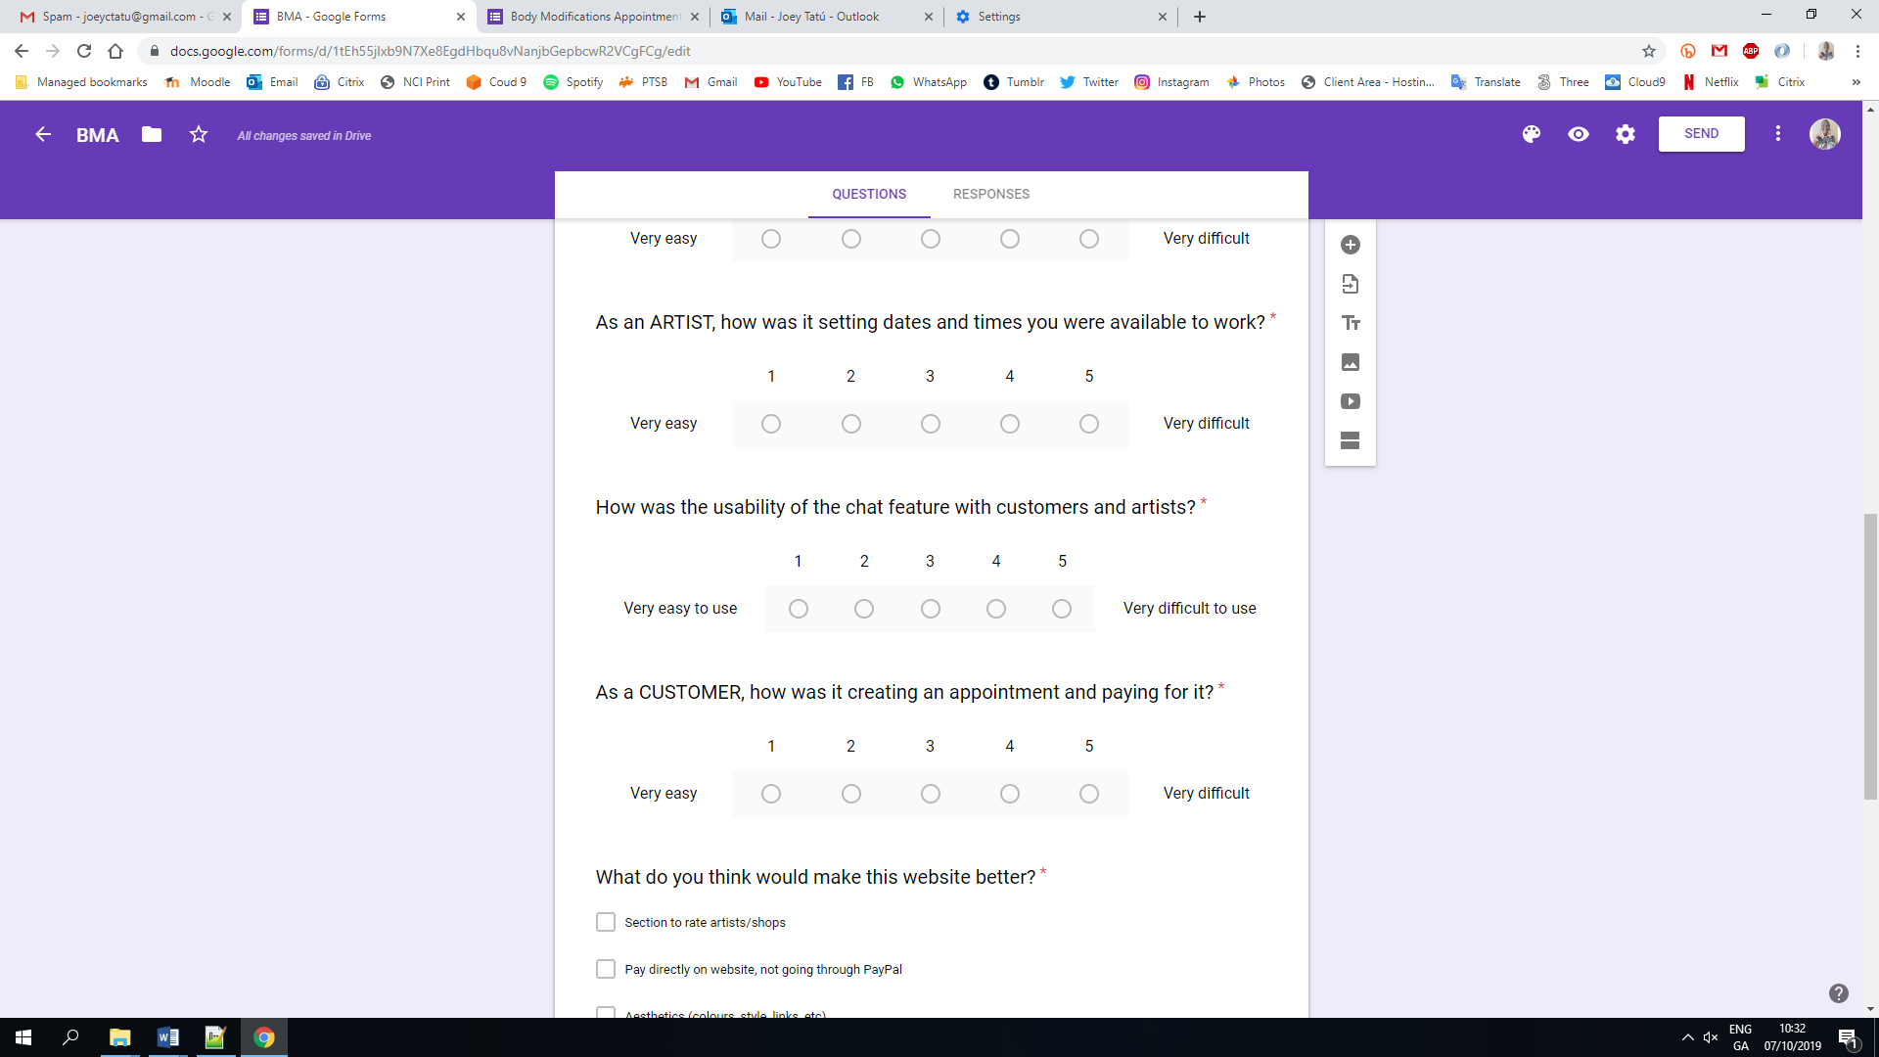

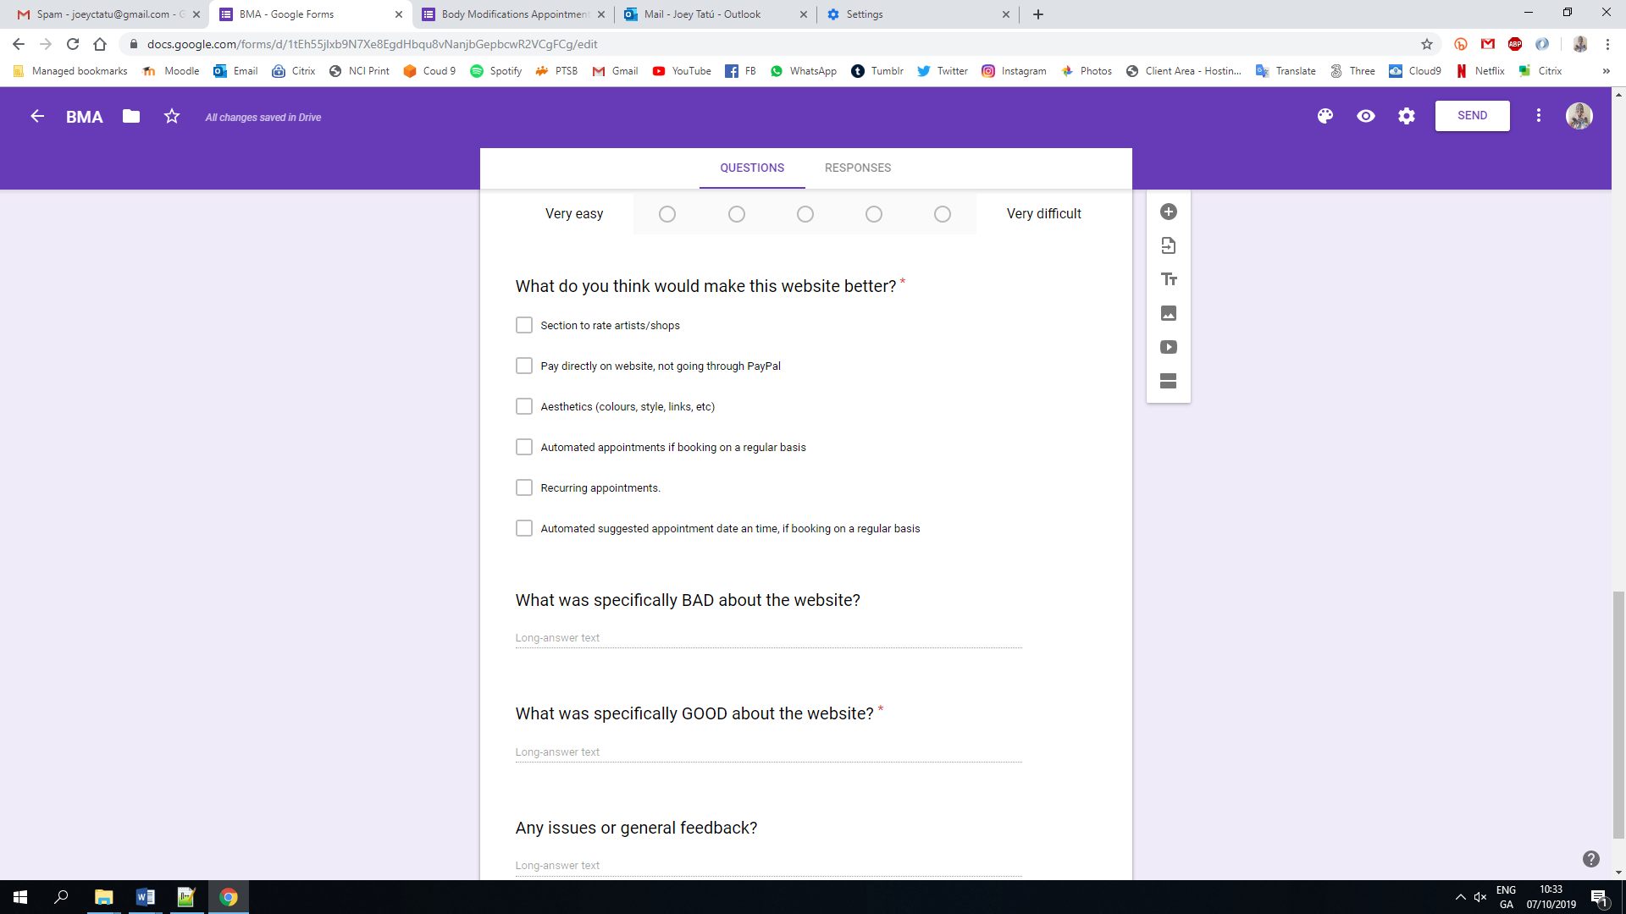

**APPENDIX B – CONSENT REQUEST**

Include here the document/ sentence/ screenshot that shows how the consent to participate in the study is requested from the participant

